

**Exploring Information and Communication Technologies (TIC) and Modern Tools**

A Comprehensive Report on Google Services, Microsoft Tools, Git, and GitHub



By:

Ziad RIMA

Abdelaziz BOUHUNALI

Houcine ROUIBAH

03 janvier 2024

# 

**Date: 01/03/2024**

Table of Contents :

Introduction: 1

Background: 1

Objectives: 2

Definition and Scope: 3

Evolution of TIC: 7

Google Services: 9

Microsoft Tools: 12

Git and GitHub: 14

Case Studies: 18

Challenges and Future Trends: 22

Final Conclusion: 24

# Introduction:

Welcome to the world of Information and Communication Technologies (TIC) – the tech that's changing the way we live and connect. In this report, we're diving deep into what TIC is all about and the cool tools that come with it. Think of TIC as the wizard behind the curtain, making your devices talk to each other and helping you do all sorts of amazing things online.

# Background:

So, how did we get here? Picture a time when computers were massive and the internet wasn't a thing. Fast forward, and now we're in the middle of a digital revolution. TIC is the superhero that emerged from this tech evolution, connecting us, powering our smartphones, and making the internet a bustling hub of information. From emails to social media, TIC is the force that keeps everything buzzing in our digital world.

# 

# Objectives:

1. **Definition and Scope**
2. **Evolution of TIC**
3. **Google Services**
4. **Microsoft Tools**
5. **Git and GitHub**
6. **Case Studies**
7. **Challenges and Future Trends**
8. **Conclusion**

# Definition and Scope:



At its core, TIC refers to the convergence of Information Technologies and Communication Technologies, collectively facilitating the management, transmission, and utilization of data in digital environments. It is the invisible force powering the seamless integration of diverse digital elements, from software applications to networked communication systems.

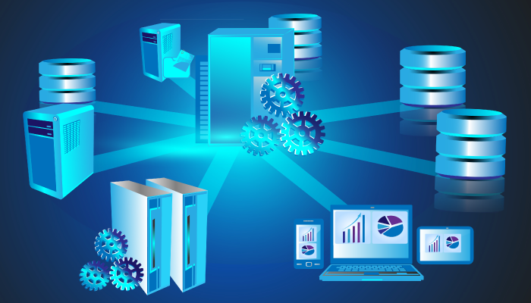**Information Technologies (IT):**

Within the domain of IT, TIC encompasses the sophisticated processing and storage of data. This involves the intricate orchestration of databases, cloud computing, and information management systems. In practical terms, IT ensures the availability and accessibility of information, serving as the foundation for various digital applications and services.

**Communication Technologies (CT):**

CT, on the other hand, is the intricate web of communication protocols and infrastructures that enable the seamless flow of data between devices. This extends beyond traditional communication channels to encompass internet connectivity, wireless networks, and the frameworks that facilitate real-time collaboration.

**The Significance of TIC:**

1. **Connecting People:**
   * TIC acts as the digital bridge, fostering connectivity and communication across geographical boundaries. It underpins social platforms, collaborative tools, and virtual communication channels, facilitating global interactions.
2. **Access to Information:**
   * TIC serves as the gateway to an expansive reservoir of information. Through digital platforms and networks, individuals gain unprecedented access to knowledge, research, and resources.
3. **Advancements in Automation:**
   * The scope of TIC extends to the automation of processes and operations. It is the driving force behind smart technologies, enabling the automation of homes, industries, and various facets of daily life.

*SOURCE: Hexa Research*

**Scope of TIC:**

1. **Application and Software Development:**

* TIC fuels the development of applications and software solutions. From enterprise applications to consumer-oriented software, TIC is the catalyst for innovation in the digital realm.

1. **Networks and Connectivity:** 
   * TIC governs the design and implementation of networks, ensuring seamless connectivity. This includes the internet infrastructure, local networks, and the protocols that enable efficient data transfer.
2. **Digital Devices and Gadgets:**
   * The proliferation of digital devices, ranging from smartphones to IoT (Internet of Things) gadgets, falls within the purview of TIC. It shapes the design and functionality of these devices, contributing to the evolution of the digital ecosystem.
3. **Cybersecurity Measures:** 
   * In the era of pervasive connectivity, TIC assumes a critical role in cybersecurity. It involves the development and implementation of measures to safeguard digital assets, data integrity, and user privacy.

**Conclusion:**

As we navigate the intricate landscape of TIC, it becomes evident that this fusion of technologies not only defines our present but also lays the groundwork for the future. The subsequent sections of this report will delve deeper into specific facets of TIC, unraveling the complexities and implications of the digital tapestry that envelops our lives.

# Evolution of TIC:

**Early Foundations:**

The roots of TIC can be traced back to the mid-20th century when computing devices were in their infancy. The advent of mainframe computers marked the first step, with limited processing capabilities and colossal physical footprints. These early machines laid the groundwork for the subsequent digital revolution, paving the way for smaller, more powerful computing devices.

**The Digital Revolution:**

The latter half of the 20th century witnessed the acceleration of TIC with the advent of microprocessors and personal computers. The rise of the internet in the late 20th century acted as a catalyst, propelling TIC into a new era of interconnectedness. Suddenly, information could be shared globally, and the concept of a digital society began to take shape.

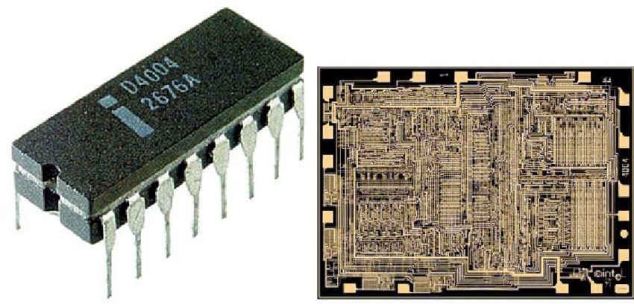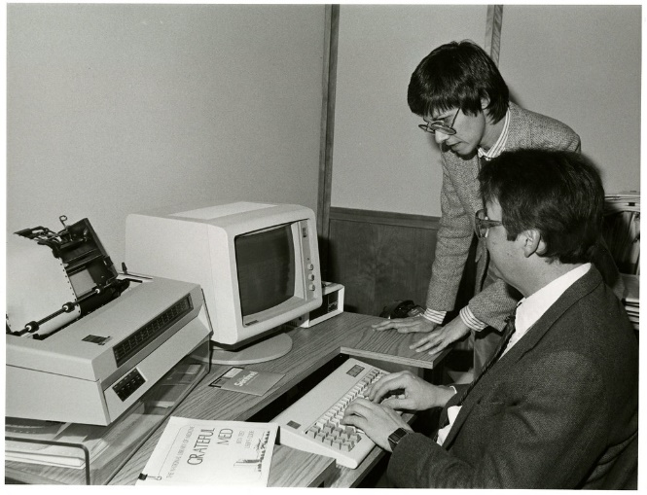

**The Internet Era:**

The 21st century ushered in the Internet era, transforming TIC from a collection of disparate technologies into a cohesive and interconnected ecosystem. Broadband internet, mobile devices, and the rise of social media platforms fueled a digital renaissance. TIC became synonymous with accessibility, as individuals gained unprecedented connectivity and access to information.

**Emergence of Smart Technologies:**

As we moved deeper into the 21st century, TIC evolved to embrace smart technologies. Smartphones, IoT devices, and interconnected systems became integral components of our daily lives. The marriage of TIC with artificial intelligence further enhanced the capabilities of digital systems, enabling predictive analytics, natural language processing, and machine learning applications.

**The Present Landscape:**

Today, we find ourselves in a digital landscape where TIC is woven into the fabric of society. From cloud computing and edge computing to the proliferation of 5G networks, TIC continues to evolve rapidly. The ongoing fusion of technologies, coupled with the relentless pursuit of innovation, sets the stage for a future where the boundaries between physical and digital realities blur.

**Conclusion:**

The evolution of TIC is an ongoing narrative, marked by innovation, collaboration, and the relentless pursuit of technological advancement. Understanding this journey provides context for the intricate web of technologies that define our present digital age. As we navigate through subsequent sections, we will delve into specific aspects of TIC, unraveling the layers of complexity that contribute to its continued evolution.

# Google Services:

Google, a name synonymous with the digital age, offers a suite of services that has become integral to our daily lives. This section explores the diverse array of Google Services, ranging from communication and productivity tools to cloud-based solutions. From the ubiquitous Gmail to collaborative platforms like Google Docs, each service plays a unique role in shaping our digital experiences.

**Overview of Key Google Services:**

1. **Gmail:** 
   * Gmail, Google's email service, redefined electronic communication. Known for its user-friendly interface, powerful search capabilities, and expansive storage, Gmail has become a cornerstone of personal and professional correspondence.

*SOURCE: DemandSage*

1. **Google Docs, Sheets, and Slides:** 
   * These collaborative tools revolutionized document creation, spreadsheet management, and presentation design. With real-time editing, seamless sharing, and cloud-based storage, they facilitate efficient teamwork and information sharing.
2. **Google Drive:**
   * Google Drive serves as a cloud storage solution, allowing users to store and access files from any device. Its integration with other Google Services enhances collaborative work by providing a centralized repository for documents, images, and multimedia.
3. **Google Calendar:**
   * A digital planner and scheduling tool, Google Calendar streamlines time management. Its features include event scheduling, reminders, and the ability to share calendars, making it a valuable asset for individuals and teams.

“We have the Google family calendar. Before a week starts, my wife and I sit down to decide who’s driving who to school or when can we go out on a date”

-Michael Lewis

1. **Google Meet:**
   * In the realm of virtual meetings and video conferencing, Google Meet emerges as a robust platform. Its features include high-definition video quality, screen sharing, and integration with other Google Services, making it a preferred choice for remote collaboration.

**The Impact on Collaboration and Productivity:**

Google Services have redefined the way individuals and organizations collaborate and enhance productivity. The cloud-based nature of these tools ensures seamless access to information, irrespective of geographical locations. Real-time collaboration features empower teams to work synchronously, fostering innovation and efficiency.

**Key Considerations for Users:**

While the convenience and functionality of Google Services are undeniable, users must be mindful of data privacy and security considerations. Understanding the settings related to information sharing and storage is crucial for maintaining the integrity and confidentiality of data.

**Conclusion:**

In the ever-evolving landscape of digital tools, Google Services stand out as a testament to innovation and user-centric design. As we navigate through the digital terrain, the impact of these services on communication, collaboration, and productivity becomes increasingly evident. The subsequent sections of this report will delve into additional technological pillars, unraveling their complexities and implications in the broader context of Information and Communication Technologies.

# Microsoft Tools:

Microsoft, a stalwart in the world of technology, offers a comprehensive suite of tools and applications that play a pivotal role in both personal and professional spheres. This section delves into the diverse ecosystem of Microsoft Tools, ranging from the ubiquitous Microsoft Office suite to collaborative platforms like Teams. Each tool contributes to enhancing productivity, facilitating collaboration, and driving innovation across various domains.

**Overview of Key Microsoft Tools:**

1. **Microsoft Office 365 Suite:**
   * The cornerstone of productivity, the Office 365 suite includes applications like Word, Excel, PowerPoint, and more. These tools are synonymous with document creation, data analysis, and presentation design, providing a robust foundation for business and academic endeavors.
2. **Microsoft Teams:**
   * Positioned as a hub for teamwork, Microsoft Teams is a collaboration platform that integrates chat, video conferencing, file sharing, and application integration. It streamlines communication and collaboration within organizations, particularly in remote or dispersed work environments.
3. **OneDrive:** 
   * OneDrive serves as Microsoft's cloud storage solution, allowing users to store and access files from various devices. Its seamless integration with Microsoft Office applications facilitates efficient document management and collaboration.
4. **Power BI:**
   * Power BI is a business analytics tool that enables users to visualize and share insights from their data. It empowers organizations to make data-driven decisions by transforming raw data into meaningful visualizations and reports.
5. **Azure DevOps:** 
   * For software development teams, Azure DevOps provides a set of development tools and services that facilitate collaboration, code management, automated testing, and continuous integration and delivery (CI/CD) processes.

**Enhancing Business Productivity:**

Microsoft Tools collectively contribute to enhancing business productivity by providing a cohesive ecosystem for communication, collaboration, and data management. The seamless integration of these tools allows users to transition seamlessly between applications, fostering a unified and efficient work environment.

**The Role in Remote Work and Collaboration:**

Particularly relevant in the era of remote work, Microsoft Tools have played a crucial role in supporting virtual collaboration. Microsoft Teams, with its diverse features, serves as a virtual workspace where teams can connect, share information, and collaborate on projects irrespective of geographical constraints.

**Considerations for Integration:**

While the integration of Microsoft Tools offers a streamlined experience, organizations should consider factors such as data security, user training, and system compatibility when implementing these solutions.

**Conclusion:**

Microsoft's commitment to innovation is evident in the suite of tools designed to empower individuals and organizations. As we navigate through the technological landscape, the impact of Microsoft Tools on modern work practices becomes increasingly apparent. The subsequent sections of this report will continue to unravel the layers of Information and Communication Technologies, shedding light on additional components that define our digital experiences.

# Git and GitHub:

In the realm of software development and version control, Git and GitHub stand as cornerstones of collaboration, code management, and project tracking. This section delves into the intricacies of Git, a distributed version control system, and GitHub, a web-based platform that facilitates collaborative development. Together, they form a powerful duo that has revolutionized the way software is built and maintained.

**Understanding Git:**

1. **Version Control:** 
   * Git is a version control system that tracks changes in source code during software development. It allows multiple developers to collaborate on a project, keeping track of each change made to the codebase.



1. **Branching and Merging:** 
   * One of Git's strengths lies in its ability to create branches for parallel development. Developers can work on separate branches, and Git facilitates the merging of these branches, preventing conflicts and ensuring a smooth integration of changes.
2. **Local and Remote Repositories:**
   * Git operates with both local and remote repositories. Developers can make changes locally and then push those changes to a remote repository, enabling a distributed and collaborative development workflow.

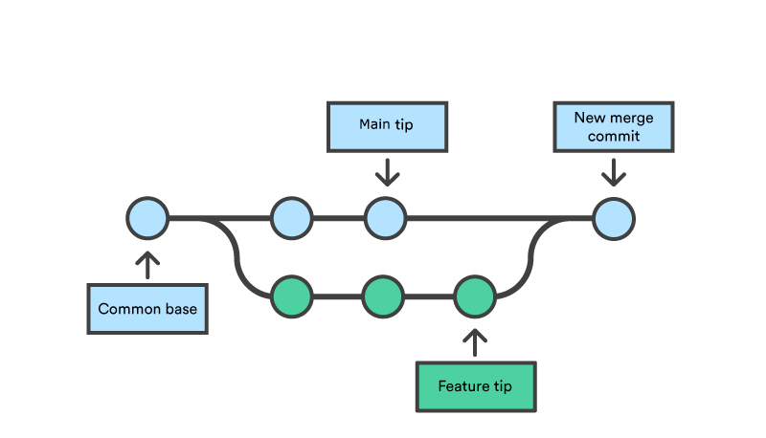

**Understanding GitHub:**

1. **Web-Based Collaboration:**
   * GitHub is a web-based platform built around Git, providing a collaborative space for developers. It allows teams to host and review code, manage projects, and build software collaboratively.
2. **Pull Requests:**
   * GitHub introduces the concept of pull requests, where developers propose changes to a codebase. This mechanism facilitates code review, discussion, and the integration of changes into the main code repository.
3. **Issue Tracking:**
   * GitHub's issue tracking system allows teams to manage and prioritize tasks, track bugs, and discuss enhancements. It serves as a centralized hub for project management and communication.

**Significance in Software Development:**

1. **Collaboration Efficiency:** 
   * Git and GitHub enhance collaboration efficiency by providing a structured and organized environment for multiple developers to contribute to a project concurrently. The ability to work on separate branches and merge changes seamlessly fosters a streamlined development process.
2. **Open Source Contributions:** 
   * GitHub has become a hub for open source contributions, enabling developers worldwide to collaborate on projects. The platform's accessibility and pull request mechanisms have democratized the contribution process.
3. **Project Transparency:** 
   * Both Git and GitHub promote transparency in software development. Git's version control ensures a clear history of code changes, while GitHub's features like issues and pull requests provide visibility into the project's development lifecycle.

**Considerations for Development Teams:**

While Git and GitHub offer powerful collaboration tools, development teams should establish clear branching and merging strategies, implement effective code review processes, and ensure proper documentation to maximize their benefits.

**Conclusion:**

Git and GitHub represent a paradigm shift in the landscape of software development. Their adoption has not only streamlined collaborative coding efforts but has also contributed to the open and transparent nature of modern software projects. As we delve deeper into the report, additional facets of Information and Communication Technologies will be explored, shedding light on the dynamic and interconnected nature of our digital ecosystem.

# Case Studies:

Real-world applications of Information and Communication Technologies (TIC) and related tools provide tangible insights into their impact on various industries. In this section, we'll delve into compelling case studies and examples that showcase how organizations and projects have leveraged TIC to drive innovation, solve complex challenges, and achieve notable success.

**Case Study 1: Digital Transformation in Healthcare**

***Background:***

The healthcare industry has undergone a significant digital transformation, leveraging TIC to improve patient care, streamline processes, and enhance overall efficiency.

***Technologies Used:***

* Electronic Health Records (EHR) systems for centralized patient data management.

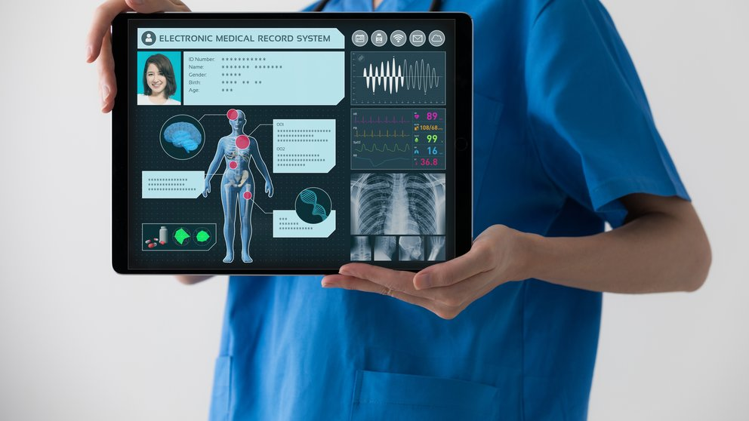

* Telemedicine platforms for remote consultations and monitoring.
* IoT devices to track patient vitals in real-time.

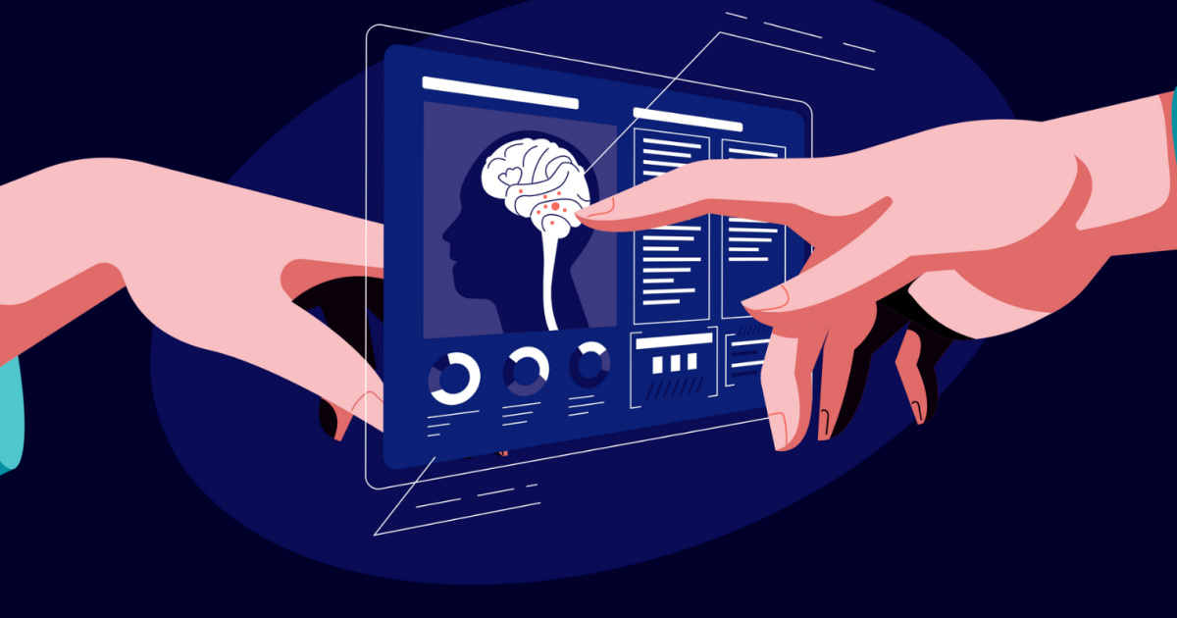

***Impact:***

This integration of TIC has resulted in improved patient outcomes, reduced administrative burdens, and increased accessibility to healthcare services. Remote patient monitoring, in particular, has proven vital in managing chronic conditions and ensuring timely interventions.

*SOURCE: Office of the National Coordinator for Health Information Technology*

**Case Study 2: Agile Collaboration in Software Development**

***Background:***

A software development company adopted agile methodologies and employed TIC tools such as Git and GitHub to enhance collaboration among globally distributed development teams.

***Technologies Used:***

* Git for version control and collaborative coding.
* GitHub for project management, code review, and issue tracking.

***Impact:***

By embracing agile practices supported by TIC tools, the company achieved faster release cycles, minimized code conflicts, and improved overall code quality. The transparent and collaborative nature of the development process on GitHub facilitated efficient communication among team members.

**Case Study 3: Education in the Digital Age**

***Background:***

The education sector has witnessed a paradigm shift with the integration of TIC tools, especially in the wake of remote learning and digital classrooms.

***Technologies Used:***

* Learning Management Systems (LMS) for course management and content delivery.
* Video conferencing tools for virtual classrooms.
* Cloud-based collaboration tools for student engagement.

***Impact:***

TIC tools have enabled seamless transition to online learning, providing students and educators with flexible and interactive learning environments. Virtual classrooms, collaborative document editing, and instant communication have become integral components of modern education.

**Conclusion:**

These case studies offer a glimpse into the transformative power of TIC across diverse sectors. Whether in healthcare, software development, or education, the adoption of TIC tools has proven instrumental in overcoming challenges and achieving significant advancements. As we continue our exploration, the subsequent sections will address challenges, future trends, and the broader implications of TIC on our evolving digital landscape.

# Challenges and Future Trends:

The evolution of Information and Communication Technologies (TIC) has been a remarkable journey, but it hasn't been without challenges. Additionally, as technology continues to advance, new trends emerge, shaping the future of TIC. In this section, we'll explore the existing challenges and gaze into the crystal ball to discern the trends that will define the next chapter of TIC.

**Challenges in TIC:**

1. **Cybersecurity Threats:** 
   * The interconnected nature of TIC introduces vulnerabilities, and cybersecurity threats continue to evolve. Protecting sensitive data and ensuring the integrity of digital systems remain ongoing challenges.
2. **Digital Inequality:** 
   * Not everyone has equal access to TIC, leading to digital inequality. Disparities in internet access, digital literacy, and technology infrastructure pose challenges in ensuring that the benefits of TIC are universally accessible.
3. **Data Privacy Concerns:** 
   * The extensive collection and utilization of personal data raise concerns about privacy. Striking a balance between leveraging data for innovation and protecting individual privacy is a complex challenge.
4. **Legacy System Integration:** 
   * Many organizations grapple with the integration of TIC into existing legacy systems. Transitioning from traditional to modern technologies poses technical and operational challenges.

**Future Trends in TIC:**

1. **Artificial Intelligence (AI) Integration:** 
   * The integration of AI into TIC will redefine how systems process information, automate tasks, and make decisions. From AI-driven analytics to machine learning algorithms, the future holds a symbiotic relationship between TIC and AI.
2. **5G Technology Adoption:** 
   * The widespread adoption of 5G networks will revolutionize connectivity, enabling faster data transfer, reduced latency, and the proliferation of IoT devices. This will open new possibilities for TIC applications in various domains.
3. **Edge Computing:**
   * Edge computing, bringing computation closer to data sources, will gain prominence. This trend addresses the need for real-time processing and reduced latency, particularly in applications like IoT and autonomous systems.
4. **Quantum Computing Advancements:** 
   * Quantum computing holds the potential to revolutionize computational capabilities. Although in its early stages, advancements in quantum computing may unlock new possibilities in data processing and encryption.

**Conclusion:**

While challenges persist, the future of TIC is teeming with possibilities. As technologies advance, addressing cybersecurity threats, ensuring equitable access, and navigating ethical considerations will be paramount. The trends shaping the future underscore the dynamic nature of TIC, pointing toward a future where innovation and connectivity play central roles in shaping our digital landscape. The subsequent section, the conclusion, will synthesize key insights from our exploration of TIC and its myriad components.

# Final Conclusion:

**Synthesis of Insights:**

Our exploration of Information and Communication Technologies (TIC) and related tools has been a journey through the dynamic and interconnected landscape of the digital age. From defining TIC and understanding its evolution to examining the impactful tools such as Google Services, Microsoft Tools, and Git and GitHub, we have uncovered the intricate tapestry that shapes our digital experiences.

**Key Takeaways:**

1. **TIC as a Foundation:** 
   * TIC serves as the foundational framework that underpins the digital world. It is the invisible force that facilitates communication, collaboration, and the seamless flow of information across diverse platforms and devices.
2. **Evolutionary Trajectory:** 
   * The evolution of TIC reflects a continuous journey of innovation and adaptation. From mainframe computers to the era of 5G networks, TIC has evolved, leaving an indelible mark on the way we live, work, and connect.
3. **Impactful Tools:** 
   * Tools such as Google Services, Microsoft Tools, and Git and GitHub exemplify the transformative power of TIC. They streamline communication, enhance collaboration, and empower individuals and organizations to achieve unprecedented levels of productivity and efficiency.
4. **Real-World Applications:** 
   * The case studies illustrated how TIC is not just a theoretical construct but a driving force behind tangible advancements. From healthcare to software development and education, TIC has reshaped industries and improved the quality of services.
5. **Challenges and Future Trends:** 
   * While TIC has brought about monumental advancements, it is not without challenges. Cybersecurity threats, digital inequality, and privacy concerns underscore the importance of responsible technological development. Looking ahead, trends such as AI integration, 5G adoption, edge computing, and quantum computing herald a future where TIC continues to redefine the boundaries of what is possible.

**The Continuing Journey:**

As we conclude this exploration, it is evident that TIC is an ever-evolving landscape with vast potential and complex challenges. The journey doesn't end here; it continues as we embrace technological advancements, address ethical considerations, and strive for a future where TIC contributes positively to the well-being of individuals and the progress of society.

**Acknowledgments:**

We extend our gratitude to the pioneers, innovators, and visionaries who have propelled the field of TIC forward. The collaborative efforts of individuals and organizations around the globe contribute to the ongoing narrative of technological evolution.

**Final Thoughts:**

In the digital age, Information and Communication Technologies are not just tools; they are enablers of possibilities. As we navigate the ever-changing landscape, let us remain cognizant of the responsibilities that come with technological advancements, ensuring that the benefits of TIC are inclusive, ethical, and sustainable.

This concludes our comprehensive report on TIC and related technologies. May our ongoing exploration of the digital frontier be marked by curiosity, innovation, and a commitment to shaping a future where technology serves the greater good.